Program 1
// Program to add 2 matrices

#include<stdio.h>
int main(){
int a[10][10],b[10][10],c[10][10],m,n,i,j;
printf("Enter no. of rows and columns:\n");
scanf("%d %d",&m,&n);

printf("\nEnter elements of 1st matrix:\n");
for(i=0;i<m;i++){
for(j=0;j<n;j++)
scanf("%d",&a[i][j]);
}

printf("\nEnter elements of 2nd matrix:\n");
for(i=0;i<m;i++){
for(j=0;j<n;j++)
scanf("%d",&b[i][j]);
}

for(i=0;i<m;i++){
for(j=0;j<n;j++)
c[i][j]=a[i][j]+b[i][j];
}

printf("\nFinal Matrix:\n");
for(i=0;i<m;i++){
for(j=0;j<n;j++)
printf("%d ",c[i][j]);
printf("\n\n");
}

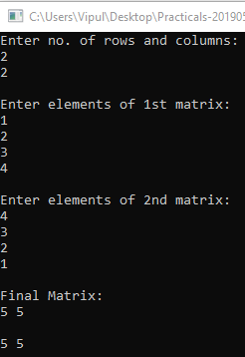
}
Program 2
// Program to subtract 2 matrices

#include<stdio.h>
int main(){
int a[10][10],b[10][10],c[10][10],m,n,i,j;
printf("Enter no. of rows and columns:\n");
scanf("%d %d",&m,&n);

printf("\nEnter elements of 1st matrix:\n");
for(i=0;i<m;i++){
for(j=0;j<n;j++)
scanf("%d",&a[i][j]);
}

printf("\nEnter elements of 2nd matrix:\n");
for(i=0;i<m;i++){
for(j=0;j<n;j++)
scanf("%d",&b[i][j]);
}

for(i=0;i<m;i++){
for(j=0;j<n;j++)
c[i][j]=a[i][j]-b[i][j];
}

printf("\nFinal Matrix:\n");
for(i=0;i<m;i++){
for(j=0;j<n;j++)
printf("%d ",c[i][j]);
printf("\n\n");
}

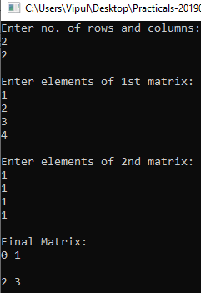
}
Program 3
// Program to multiply 2 matrices

#include<stdio.h>
int main(){
int a[10][10],b[10][10],c[10][10],m,n,p,q,i,j,k,sum=0;
printf("Enter no. of rows and columns of Matrix 1:\n");
scanf("%d %d",&m,&n);

printf("\nEnter elements of 1st matrix:\n");
for(i=0;i<m;i++){
for(j=0;j<n;j++)
scanf("%d",&a[i][j]);
}

printf("\nEnter no. of rows and columns of Matrix 2:\n");
scanf("%d %d",&p,&q);

printf("\nEnter elements of 2nd matrix:\n");
for(i=0;i<p;i++){
for(j=0;j<q;j++)
scanf("%d",&b[i][j]);
}

if(n==p){

for(i=0;i<m;i++){
for(j=0;j<q;j++){
for(k=0;k<p;k++){
sum+=a[i][k]*b[k][j];
}
c[i][j]=sum;
sum=0;
}
}

printf("\nFinal Matrix:\n");
for(i=0;i<m;i++){
for(j=0;j<q;j++)
printf("%d ",c[i][j]);
printf("\n\n");
}

}

else{
printf("\nThe no. of columns of matrix 1 must be equal to no. of rows of matrix 2\n\n");
}
}
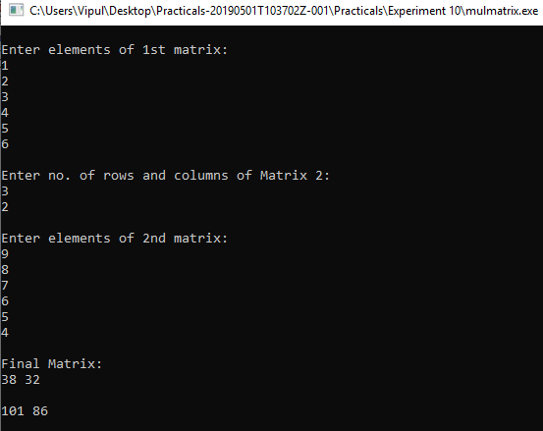
Program 4
// Program to transpose a matrix

#include<stdio.h>
int main(){
int a[10][10],b[10][10],m,n,i,j;
printf("Enter no. of rows and columns:\n");
scanf("%d %d",&m,&n);

printf("\nEnter elements of the matrix:\n");
for(i=0;i<m;i++){
for(j=0;j<n;j++)
scanf("%d",&a[i][j]);
}

for(i=0;i<n;i++){
for(j=0;j<m;j++)
b[i][j]=a[j][i];
}

printf("\nOriginal Matrix:\n");
for(i=0;i<m;i++){
for(j=0;j<n;j++)
printf("%d ",a[i][j]);
printf("\n\n");
}

printf("\nTranspose of Matrix:\n");
for(i=0;i<n;i++){
for(j=0;j<m;j++)
printf("%d ",b[i][j]);
printf("\n\n");
}

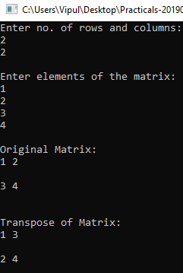
}
Program 5
// Program to demonstrate the use of following string handling functions – strrev(), strcmp(), strcat(), strlen(), strstr().

#include<stdio.h>
#include<string.h>
int main(){
char str1[100],str2[]="world";

printf("Enter a string: ");
gets(str1);

if(!strcmp(str2,str1))
puts("\nEqual Strings");
else
puts("\nNot Equal Strings");

printf("\nString 1 Length = %d\n",strlen(str1));

char *pos=strstr(str1,str2);
if(pos){
printf("\nString found at: ");
puts(pos);
printf("\n");
}
else {
printf("\nString not found\n");}

puts(strcat(str2,str1));

printf("\nReversed String: ");
puts(strrev(str1));
}

